FOOD (Project FD)

A game by Peter Darmawan [and future team]

Genre

The genre of this game would be:

* Point-and-click
* Role-playing
* Fixed perspective
* Pressure-management/Time-management

Platform

* PC (Main Platform)
* Mobile (consideration)

Pitch

You take the role of different chefs running their own respective restaurants. Each restaurant serves their own unique dishes (for example, a noodle shop constantly serves its unique chicken noodles, a fried rice shop serves its unique fried rice, a chicken shack serves its unique fried chicken, etc). Every food tells a story that would relate to the story of the chefs that are cooking them.

Theme

* Fixed perspective gameplay
* Simplistic
* Semi-realistic
* Colourful
* Foodie
* Low Poly

Core Experience

The game would show the beauty of the process of making food and the food itself. Every successful dish would give a sense of satisfaction to the player and would be mouth-watering to see.

Core Gameplay loop

As a player, you will take a first-person perspective and would be placed inside the kitchen. The player’s job is to cook and serve all orders from visiting customers. Players must put in the correct ingredients in the right order and in the right time to cook the dish. The players are given a time constraint for each order placed or else the customer would leave (like diner dash).

Design Principles

* Fixed position with the ability to rotate to different perspectives left and right.
* Point, click, and drop items.
* Visual and Audio Indicator (for example, if a soup its already boiling then it’s ready. Or if the timer rang then whatever is in the oven is ready to be taken out).
* Precise and consistent player performance would be very rewarded.
* Time constraint pressure.
* Every restaurant has at least 3 different days (levels) with increasing difficulty.

Target Audience

* Casual Players
* Foodies
* Time-management completers

Influences

* FNAF Games
* Ramen cooking mobile games

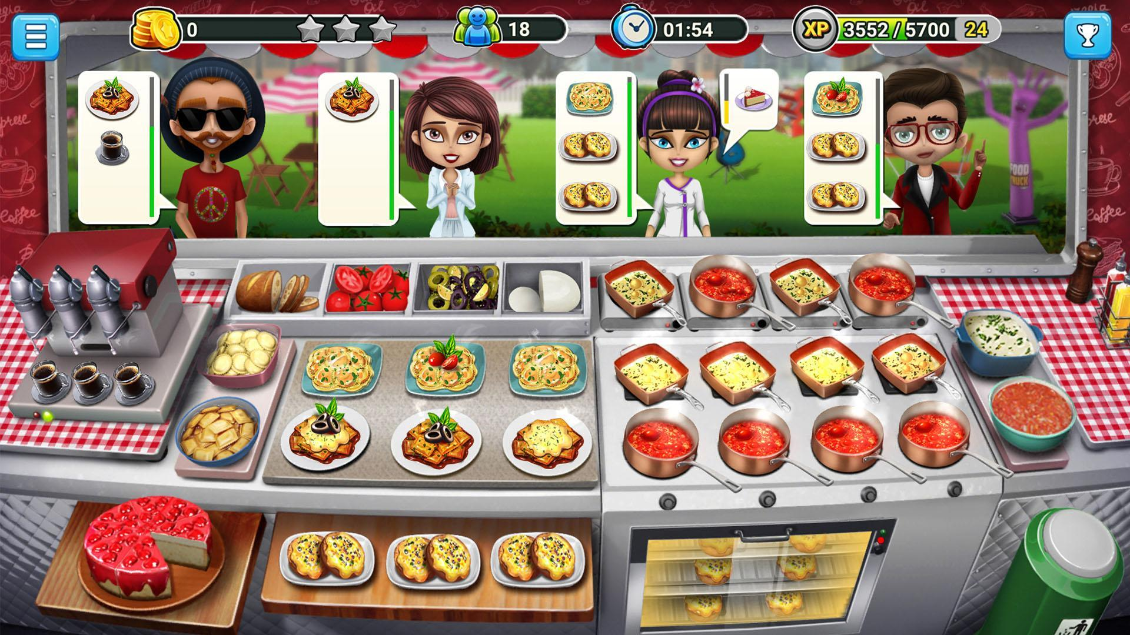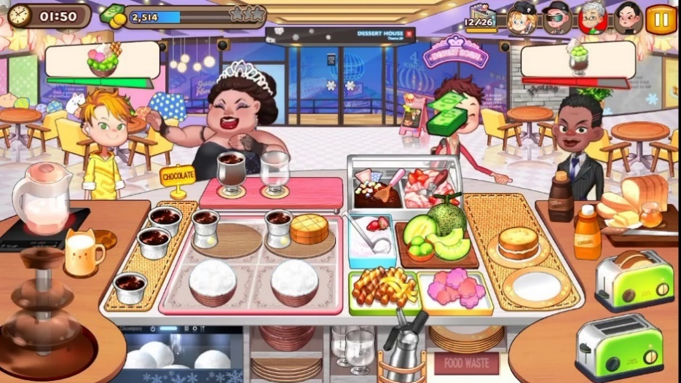

Mechanics

Fixed Player Position, Rotating Camera perspective

The player itself cannot move forward, backwards, etc. What the player can do to change his/her perspective is to rotate the camera left, right, up, or down. As of now, there are two ways we can do this:

1. **Static Rotation**

The perspectives are already pre-determined by the developers. The kitchen is divided into different segments. To Change to a new perspective, the player just needs to press the WASD keys to go to the desired segments. (Inspired from FNAF4 camera perspective. For more information, look at the tested camera mechanic made by Peter)

Drag and drop (Needs to be tested)

Players would be able to click, drag and drop ingredients in order to process them into new ingredients to create the dish. The player would be able to bring ingredients from one part of the kitchen to another part of the kitchen. For example, the player takes a bowl of chicken from the refrigerator. The player then changes perspective to another part of the kitchen and puts down the chicken.

Ingredient processing

In certain parts of the kitchen, the player would be able to process the ingredient items they have picked up. For example, the bowl of chicken that the player has placed down can be combined with egg batter and flour to create prepared chicken. This prepared chicken would be brought to the fryer to be processed into the final fried chicken food.

Time Constraint

Players would be pressured by the time left to prepare the most recent order form visiting customers. Players would be rewarded if they are able to prepare the order with a substantial amount of time left. Failure to deliver the order would result in the player not being rewarded at all.

Food Quality Constraint

Players would be pressured by quality assurance of the food they are preparing. If the player is able to deliver the food with accurate and precise quality, then customer would be pleased, and the player would be rewarded. If the food is burnt, undercooked, raw, etc. Then the customer would not be as pleased and not as rewarded.

[Everything in the Food Quality Constraint description below this line is subject to change]

Each dish being served has a “Quality Score” which will determine the total number of points that the player would receive after serving the order. The total quality score of a single dish would be determined by the multiplying the default score of each component of the dish with the quality factor. For example, the default score of each component in a cooked bowl of chicken noodles are as follows:

|  |  |
| --- | --- |
| Component of Dish | Score |
| Noodles | 5 |
| Chicken | 5 |
| Sauces | 5 |

The following table are the quality factors and the value of each of these factors

|  |  |
| --- | --- |
| Quality | Factor |
| Not Present | 0 |
| Present but prepared incorrectly | 1 |
| Present and prepared correctly | 2 |

General formula for the Total Dish Score:

$$Total Dish Score=\left({Component}_{1}×{Factor}_{1}\right)+\left({Component}_{2}×{Factor}_{2}\right)+…+({Component}_{n}×{Factor}_{n})$$

I will use the following table to illustrate the score calculation of a single bowl of noodle:

|  |  |  |  |  |
| --- | --- | --- | --- | --- |
| Component of Dish | Quality | Factor | Default Score | Final Component score |
| Noodles | Present but prepared incorrectly | 1 | 5 | 5 |
| Chicken | Present and cooked/prepared correctly | 2 | 5 | 10 |
| Sauces | Present and cooked/prepared correctly | 2 | 5 | 10 |
| Total Dish Score | | | | 25 |

General Formula for Total Order Score

$$Total Order Score={Dish Score}_{1}+ {Dish Score}_{2}+…+ {Dish Score}_{n}$$

I will use the following table to illustrate the calculation of the total order score of a single order

|  |  |
| --- | --- |
| Order Number | Score |
| 1 | 25 |
| 2 | 10 |
| 3 | 5 |
| Total Order Score | 40 |

Food Cooking Minigame

Players must make sure that they must process the food correctly. For example, players may not boil chicken more than the intended time or else it would be overcooked, or if the player takes it out too early then it would be undercooked

Other minigames would involve the player manipulating the components of the dish, so that the player would not be continuously static, but dynamic. Like button mashing or mouse wiggling.

Potential Problems

This is the first time for me and the team to attempt to create a PC-based 3D Unity game. At the start of writing this document, We are not experienced yet in handling 3D models, Colors, and still vaguely understand the Unity Particle System.

Dishes to be featured

1. **Chicken Noodles**

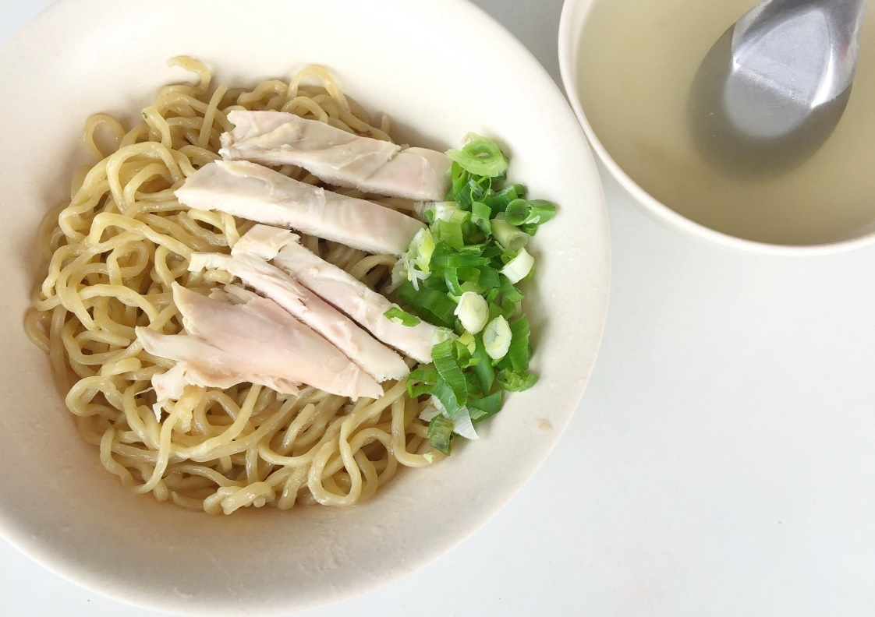

Reference: <https://pergikuliner.com/restaurants/tangerang/bakmi-ayam-dan-nasi-tim-iyan-88-gading-serpong>

1. **Fried Rice**

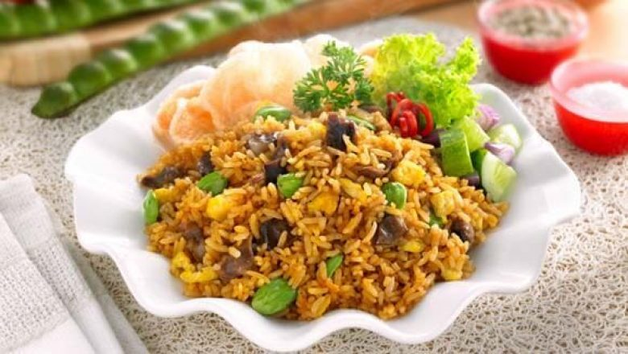

Reference: <https://jokoandri.wordpress.com/2015/02/23/nasi-goreng-seafood-bertabur-pete-enak/>

1. **Satay**

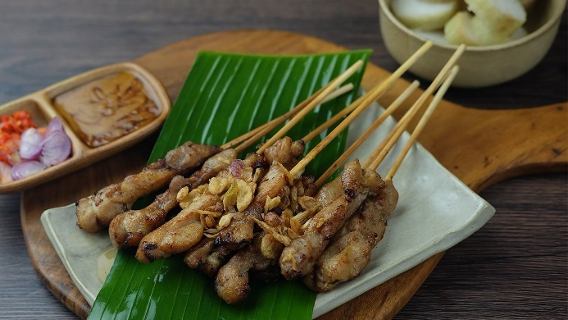

Reference: <https://www.unileverfoodsolutions.co.id/id/recipe/sate-ayam-R0071004.html>

Chicken Noodles Level Design

Kitchen Design:

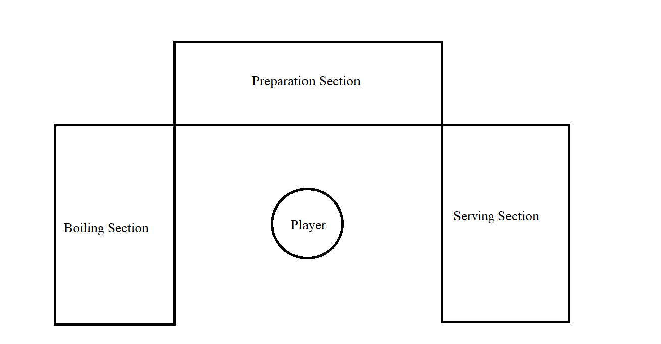

Figure 1 Kitchen Top View (Before addition of Garbage Bin)

Figure 1 is an initial top-view sketch of the kitchen. The sketch does not account for a failed dish disposal system (the garbage bin). I have sketched up another top-view for the kitchen where I temporarily placed the

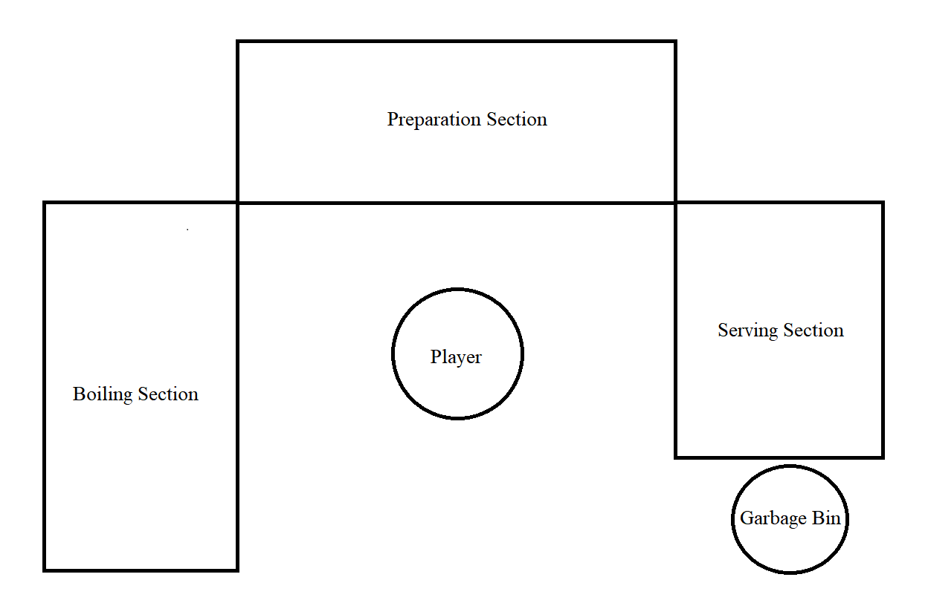

Figure 2Kitchen Top View (After addition of Garbage Bin)

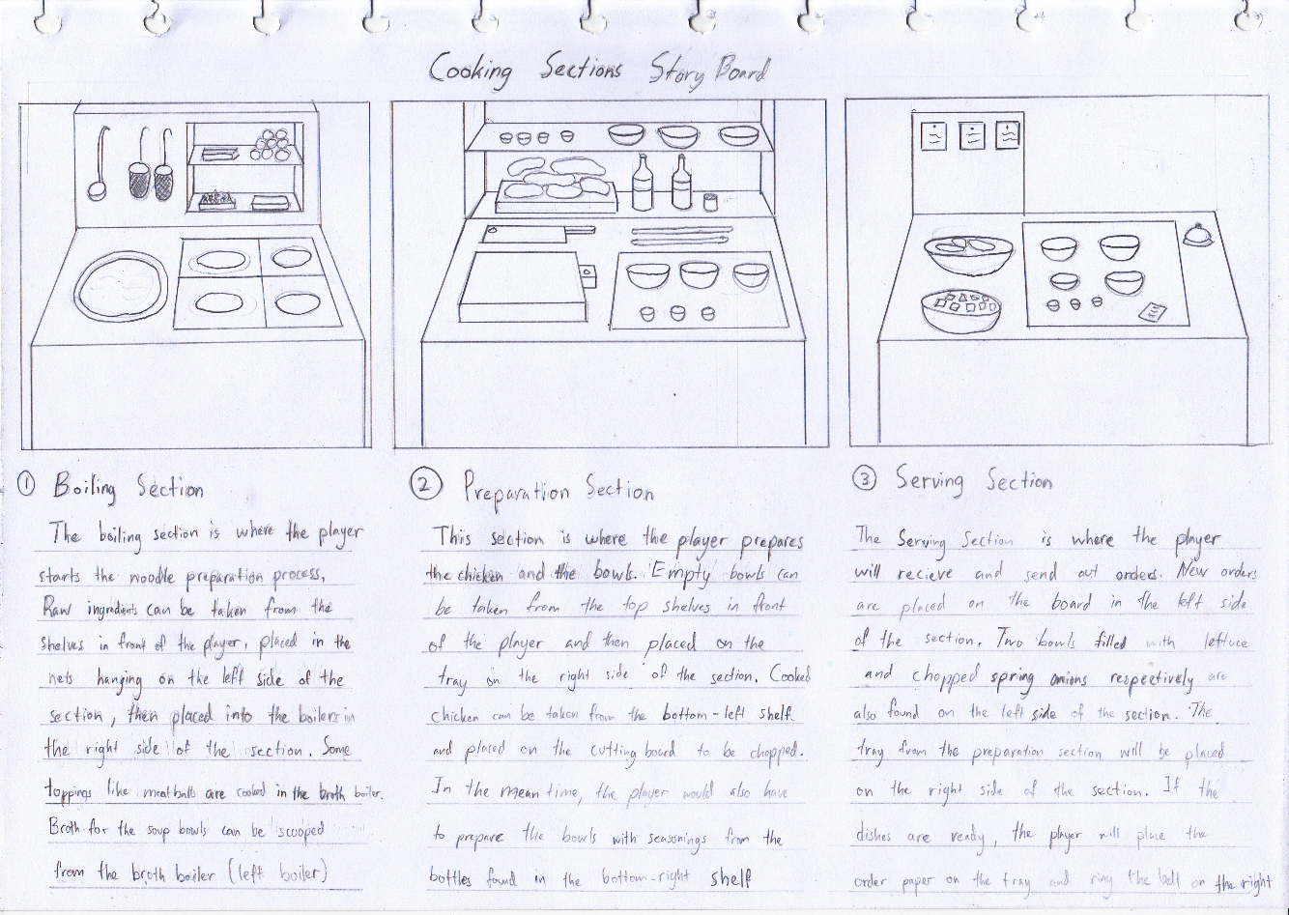

Figure 2 Kitchen Sections Story Board

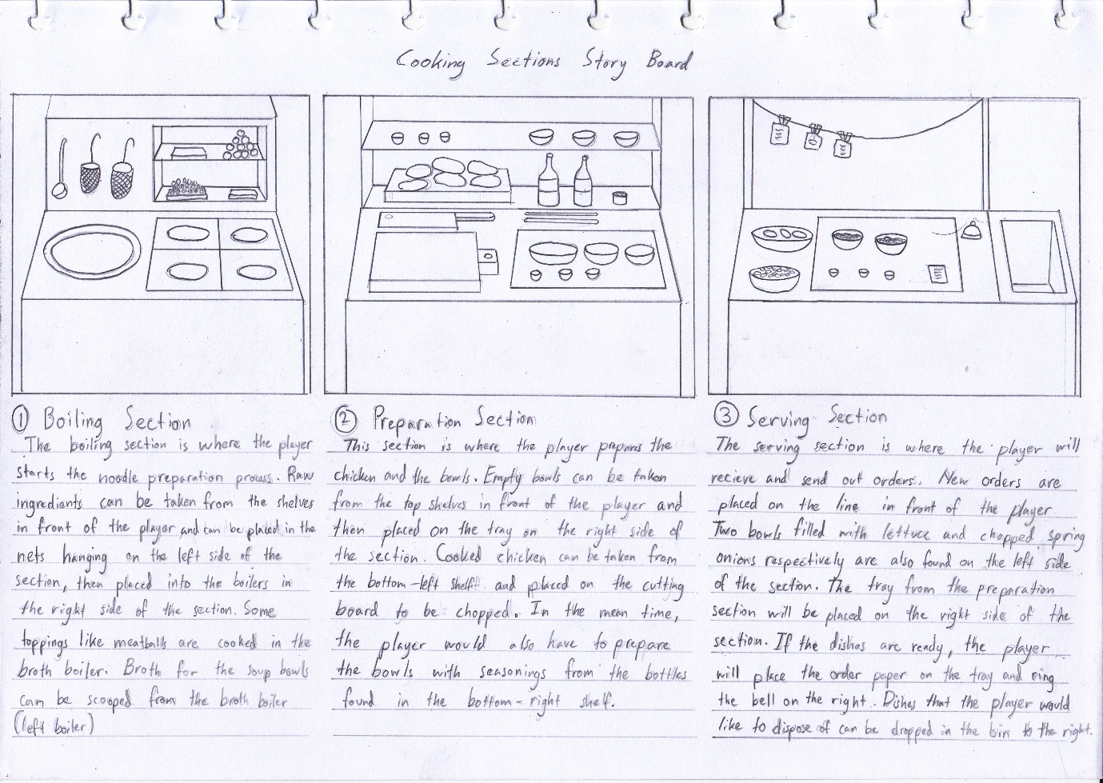

Figure 5 Cooking Section Story Board v2 (With Waste Disposal)

Mini Games:

1. **Noodle cooking**

In the boiling section, the player is expected to cook fresh noodles there. The player would have to put raw noodles into nets and place them into boilers. The boiling process would take some time. Visual and Audio indicators for the cooking process would help the player determine if the noodle is done cooking or not.

Failed noodles can be disposed in the waste disposal bin found in the serving section.

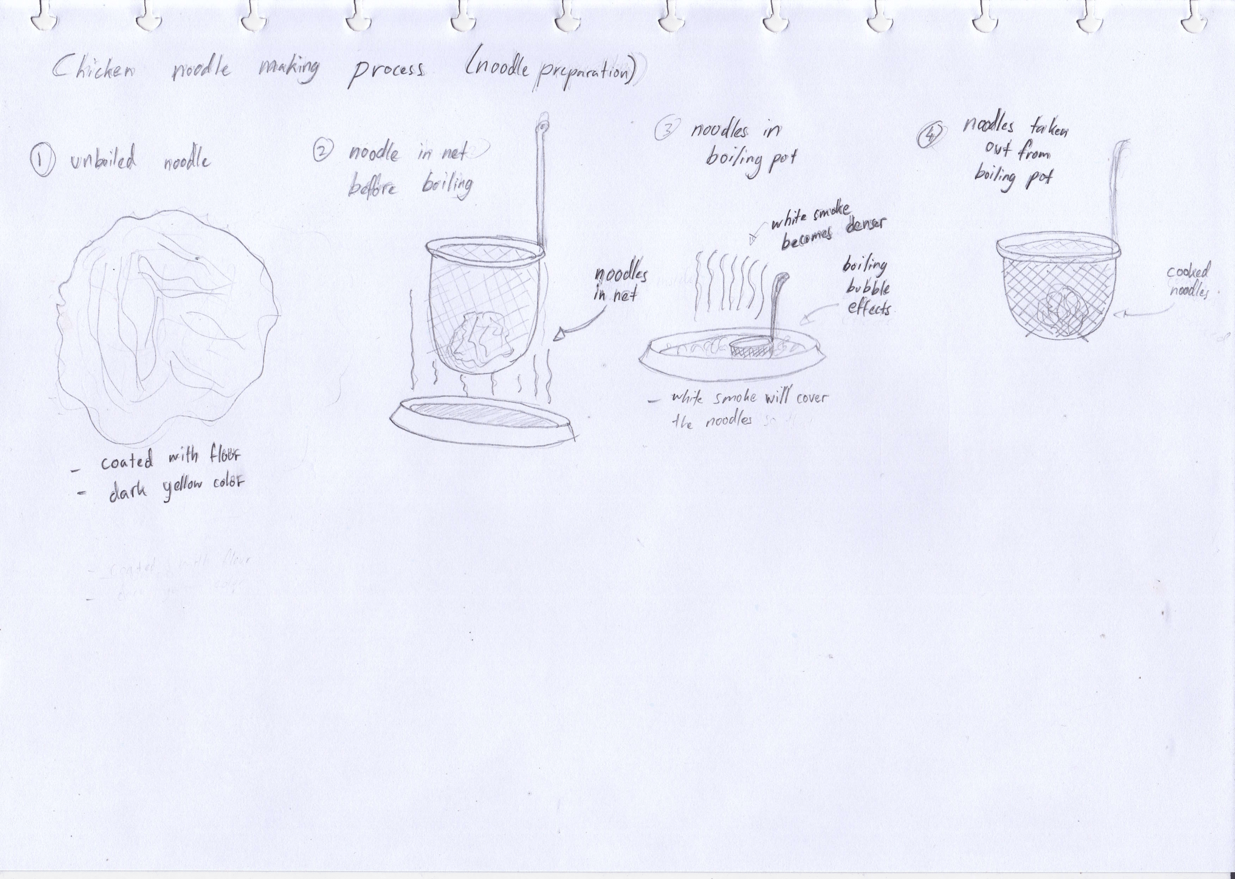

Figure Chicken Noodle Making Process

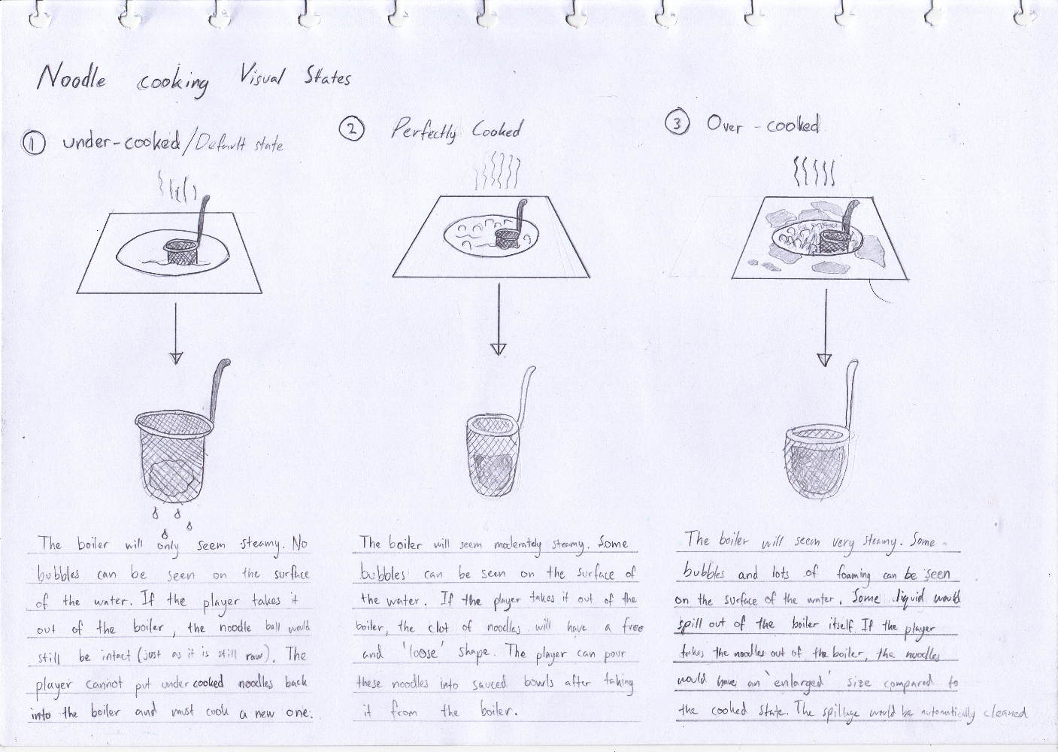

Figure Noodle Cooking Visual States

1. **Chicken preparation**

The player would prepare the chicken in the Preparation section. After the player places the chicken on top of the cutting board, he would then grab the cleaver above the cutting board to start chopping the chicken. The chopping process is not an automatic process, but rather a manual process. The player would be asked to continuously mash a button (The spacebar would be suitable for this) in order to move the chopping process forward. But the player must be careful not to mash the button too much, as cutting the chicken too much would destroy it. Mashing the button too little and the player would end up with lumps of meat. The player must mash a certain number of times so that he can get the perfect state for the component. The following table would illustrate the number of button mashes needed to reach a certain state:

|  |  |
| --- | --- |
| Visual State | Number of mashes |
| Meat lumps | <2 |
| Perfectly Cut | 4 to 5 |
| Destroyed | 6 >= (6 or more) |

The player would be able to place a full solid chicken directly into the bowl, regardless if there are noodles or not. On the other hand, the player can also put the chopped chicken into the bowl whether there are noodles or not.

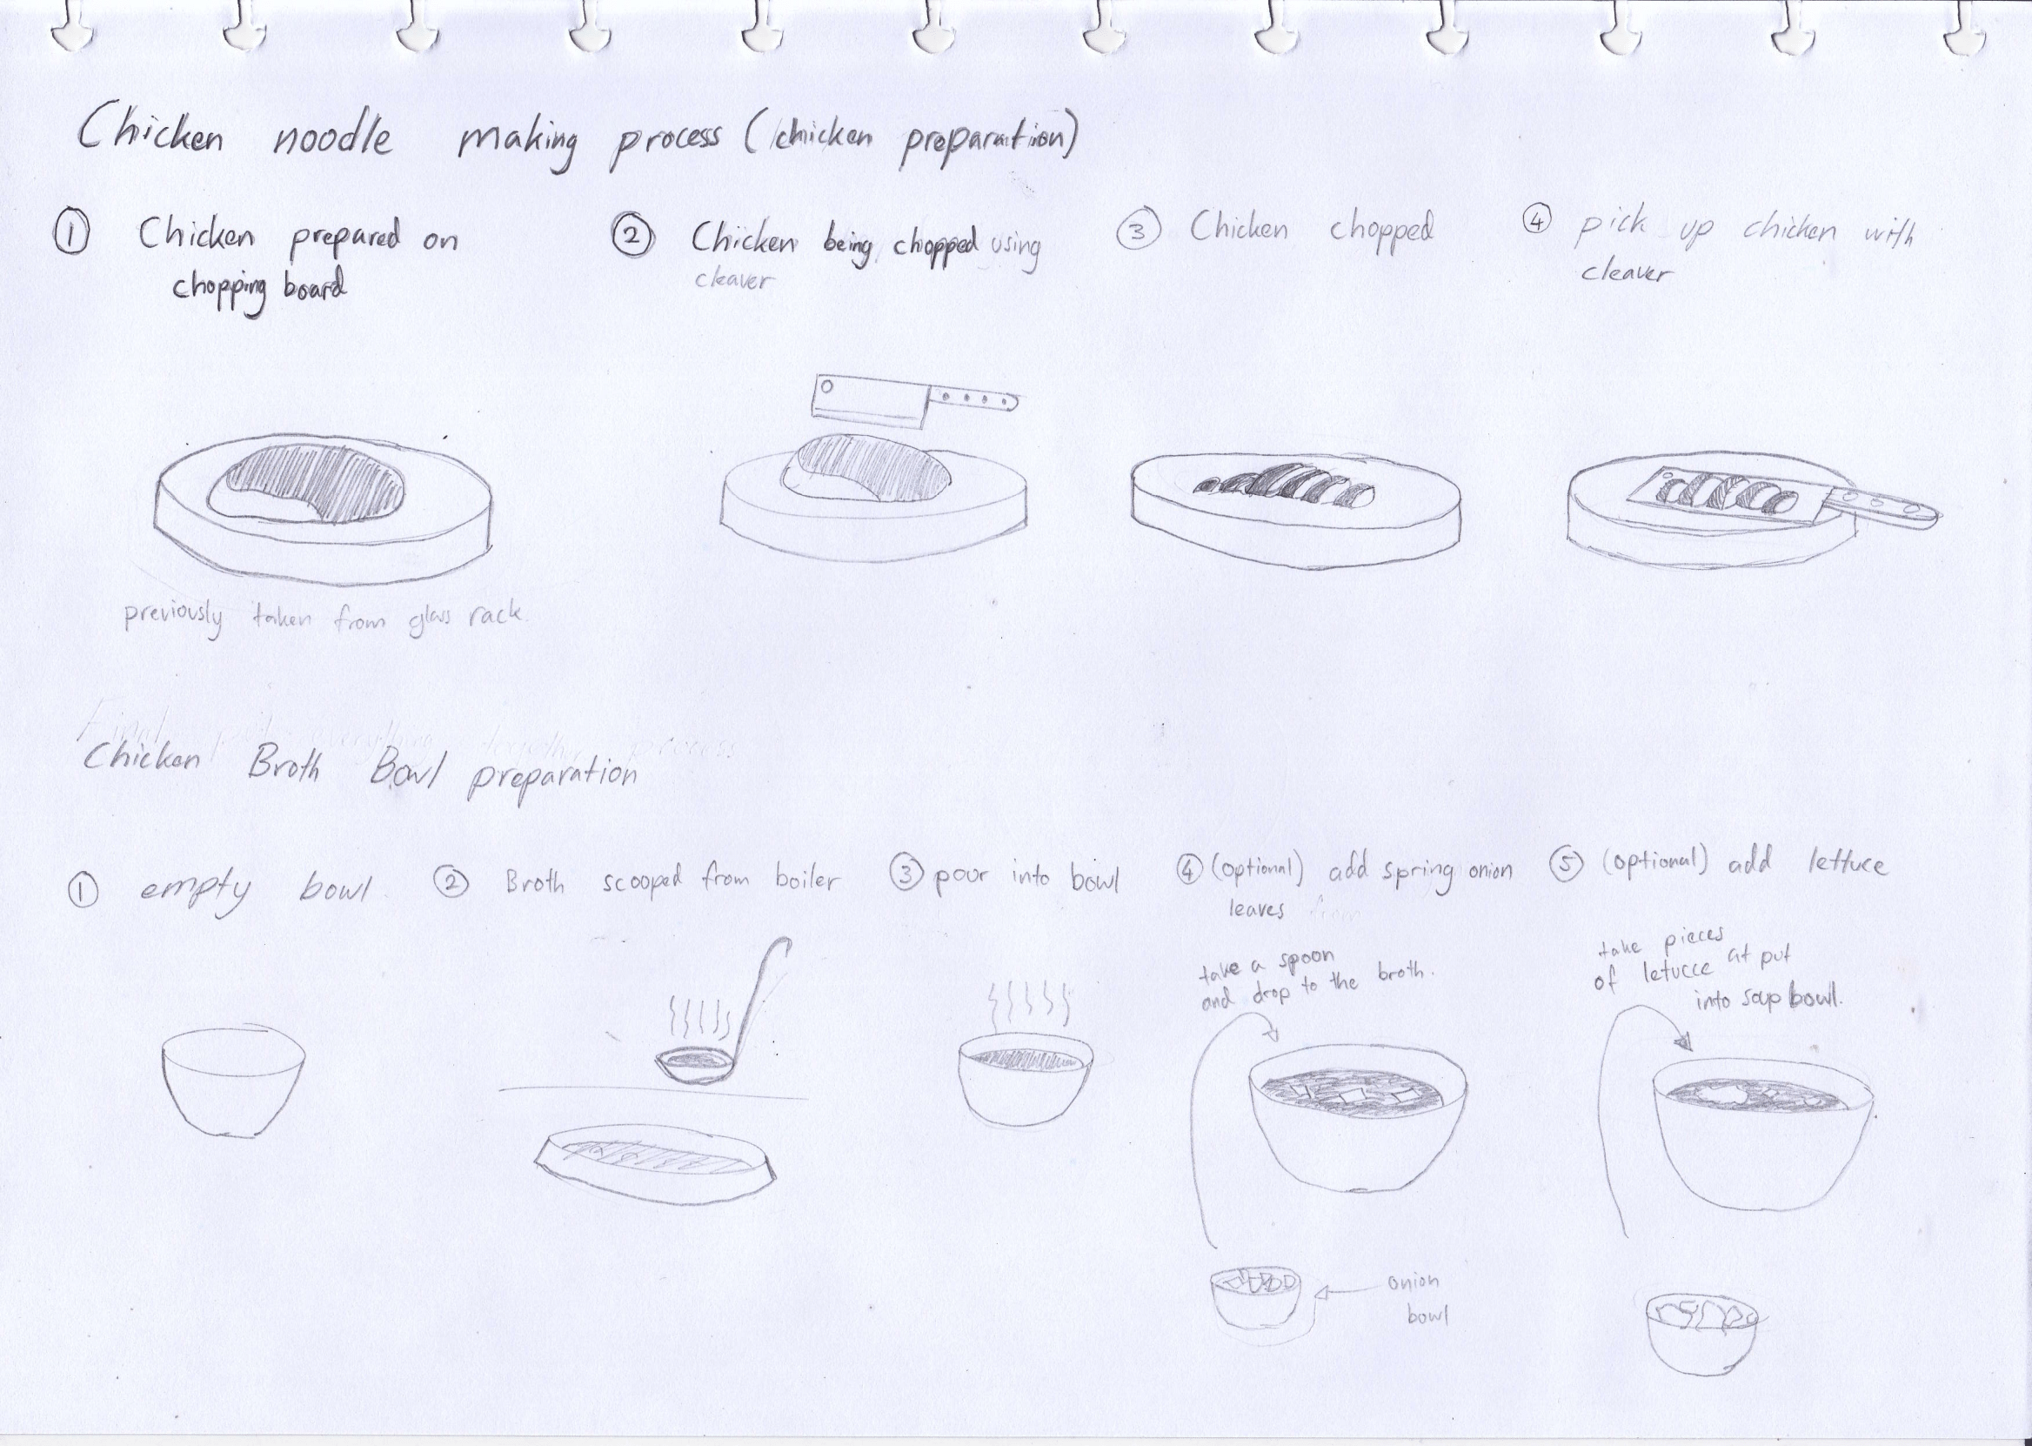

Figure Chicken Noodle Making Process (upper part of the image)

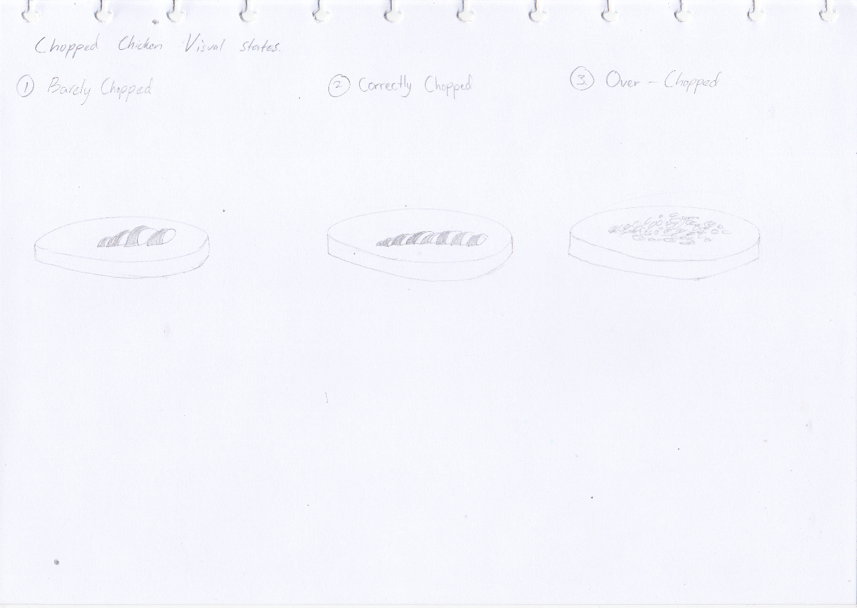

Figure 7Chicken Visual States

1. **Bowl preparation**

Like the chicken preparation minigame, if the player takes one of the seasoning bottles, the player would have to tap a button several times (the player’s hand must be above the bowls in order to do so). The following table specifies the number of taps needed for a seasoning to sauce a bowl.

|  |  |
| --- | --- |
| Item | Number of taps |
| Pepper | 1 |
| Soy Sauce | 3 |
| Chicken Oil | 2 |

If the player fails to meet the sufficient number of taps or tapped more than required (From any of the items above), then the factor would be set to 1. Only if the player taps each item correctly, then the factor would be set to 2.

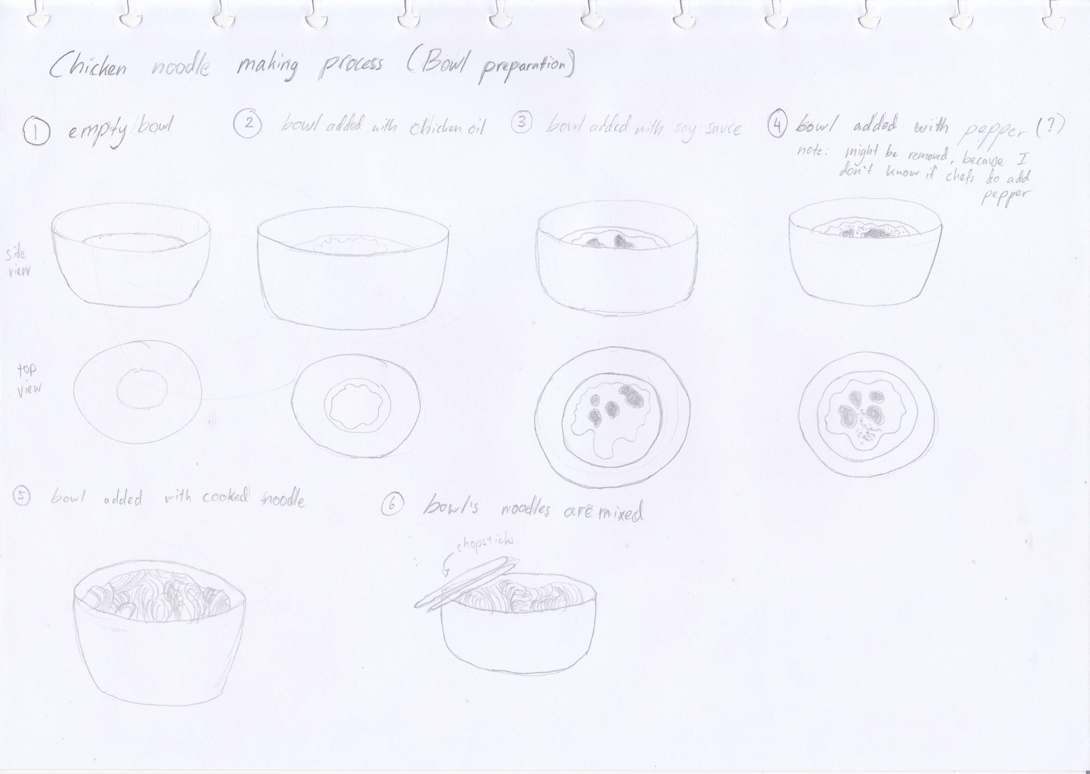

Figure Bowl Chicken Noodle Making Process

Upon pouring the noodles into the sauced bowl, the player must grab the chopsticks provided in the preparation section to mix the noodles with the seasoning. The player would mash click the bowl repeatedly, changing the colour of the noodles from bright yellow to a bit brownish or slightly darker yellow. When the player is done mixing the noodles, he/she would have to put down the chopsticks back to its place before he/she can bring the noodles to the next section.

1. **Noodle Final Composition Process**

This process will take place in the Preparation Section

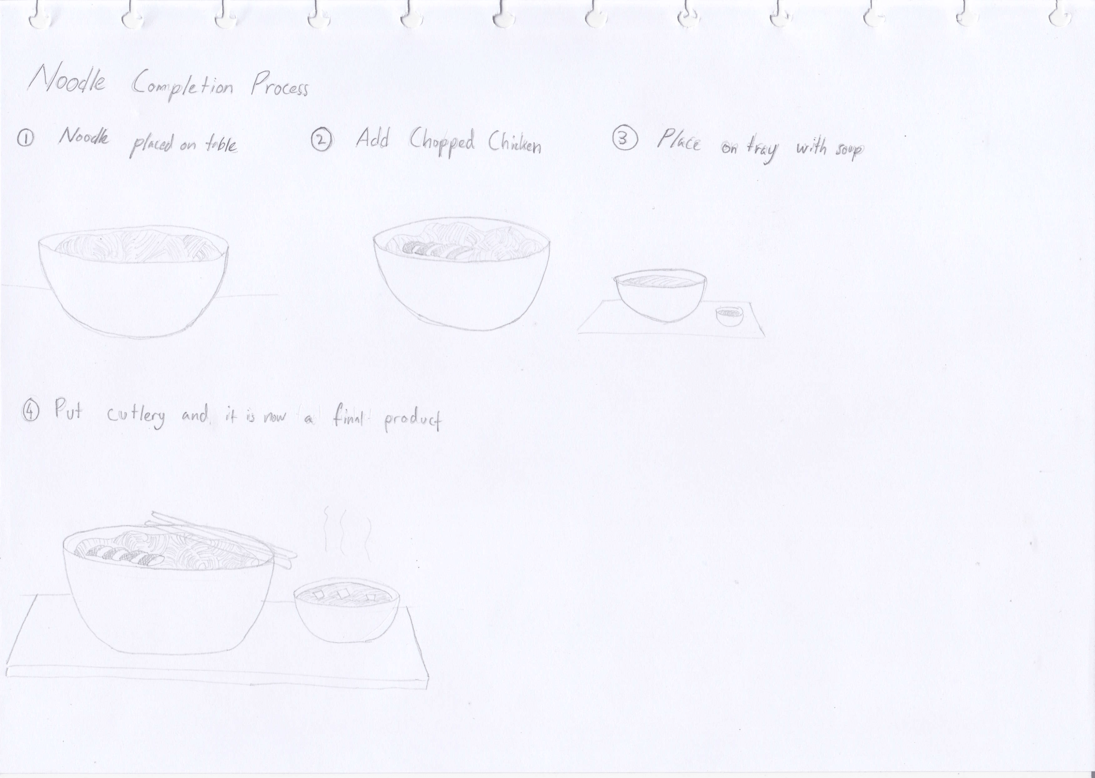

The noodle completion process would take place in the preparation section and the serving section. Steps 1 and 2 takes place in the preparation section while steps 3 and 4 takes place in the serving section. The broth bowl can be filled with broth (along with other cooked toppings such as meatballs and dumplings) from the cooking section. At the serving section, the player has the option to add 2 more toppings to the broth bowl: Lettuce or Chopped spring onions.

Color Palette

1. **Noodle**

Initially, raw noodles would have #C2AB48 as its color, then the cooked state would have a mix of #EFE1B0, #E5D298, and #B99C4E as its colors

1. **Chicken**

The cooked chicken would have a mix between #E5CBBA and #DEC3B2 as its color

1. **Lettuce**

#647F3C

1. **Chopped Spring Onion**

A mix of #3B7119, #E9F5DD, and #385F0E colors.

1. **Sauce Bottles**

#A5250A

1. **Pepper Can**

#AEA9A5

1. **Bowls**

#FEFEF4

Team Composition

**STUDIO NAME: Infinite Imagination Software (Yeet Studio)**

**Lead Programmer:** Peter Hady Nugroho Darmawan

**Junior Programmer:** Alvin

**UI Programmer**: Jason PJ

**3D Modeling:** Tun Wahid

**Animator**: Kevin Yatshen

**Sound Engineer**: Vieri Leonardy

**Documentation**: ?

NEED TO THINK MORE ABOUT:

1. Sistem Masak
2. Presepektif customer
3. Idle Animation
4. Color palette
5. Motion-style (Mau pro-realistic atau mau pro-cartoon)
6. Sound effect
7. Think about minigames, consequences, and results when cooking the ingredients (like the minigame Yatshen mentioned)
8. Make sure about the positioning of the ingredients and bowls (like spring onions)
9. Think of the shaping of each objects (like pepper grind and salt bottle)
10. Sketch up the views of each sections